MongoDB Project
Q1. List the names and departments of students who have more than 85% attendance and are skilled in both 'MongoDB' and 'Python'.
Solution: - db.students_full.find({ attendance: { $gt: 85 }, skills: { $all: ["MongoDB", "Python"] } }, { _id: 0, name: 1, department: 1 })
Explanation: -
• The condition { attendance: { $gt: 85 } } retrieves students whose attendance exceeds 85%. • The operator $all ensures that both the listed skills — "MongoDB" and "Python" — exist in the skills array. • The projection part { name: 1, department: 1 } limits the output to only the student’s name and department.
Output: -
Q2. Show all faculty who are teaching more than 2 courses. Display their names and the total number of courses they teach.
Solution: - db.faculty_full.aggregate([{ $project: { name: 1, number_of_courses: { $size: "$courses" } } }, { $match: { number_of_courses: { $gt: 2 } } }])
Explanation: -
• The $size operator counts how many elements are stored in the “courses” array.
• Then, $match filters only those records where the total course count exceeds 2.
Output: -
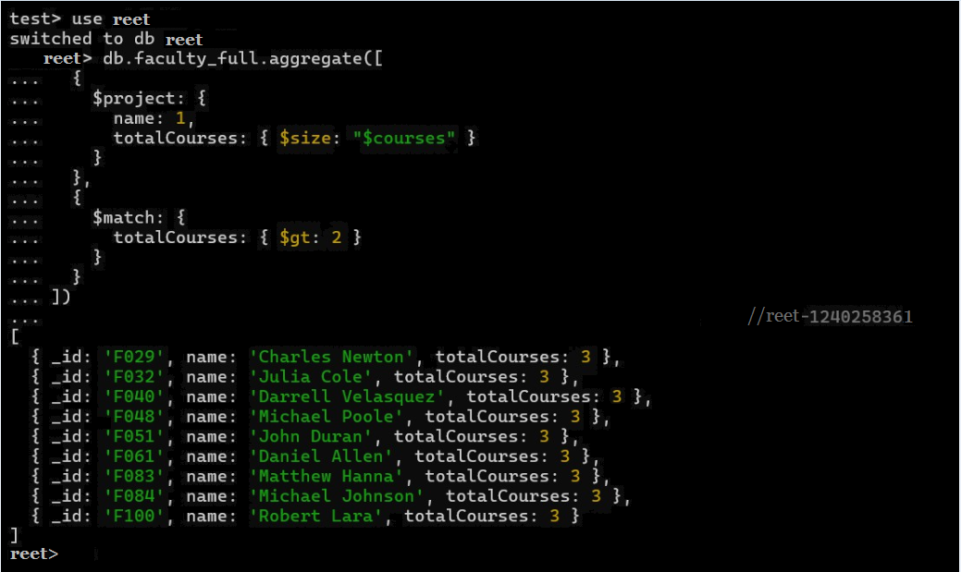
Q3. Write a query to show each student’s name along with the course titles they are enrolled in (use $lookup between enrollments, students, and courses).
Solution: -
db.enrollments_full.aggregate([
{ $lookup: { from: "students_full", localField: "student_id", foreignField: "_id", as: "student" } },
{ $unwind: "$student" },
{ $lookup: { from: "courses_full", localField: "course_id", foreignField: "_id", as: "course" } },
{ $unwind: "$course" },
{ $project: { _id: 0, student_name: "$student.name", course_title: "$course.title" } }
])
Explanation: -
• $lookup is used to join documents from multiple collections, similar to performing a JOIN operation in SQL. • $unwind flattens the resulting array into separate documents.
• $project limits output fields to show only the student’s name and course title.
Output: -
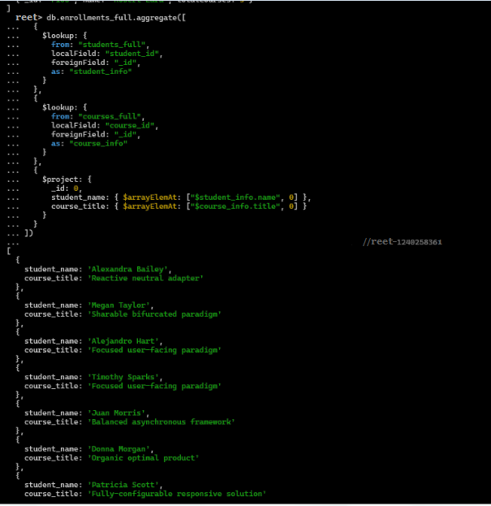
Q4. For each course, display the course title, number of students enrolled, and average marks (use $group).
Solution: -
db.enrollments_full.aggregate([
{ $lookup: { from: "courses_full", localField: "course_id", foreignField: "_id", as: "course" } },
{ $unwind: "$course" },
{ $group: { _id: "$course_id", course_title: { $first: "$course.title" }, total_students: { $sum: 1 }, average_marks: { $avg: "$marks" } } }
])
Explanation: -
• $lookup links each enrollment with its respective course. • $group groups data by course ID. • $sum counts the number of enrolled students, and $avg computes their mean marks.
Output: -
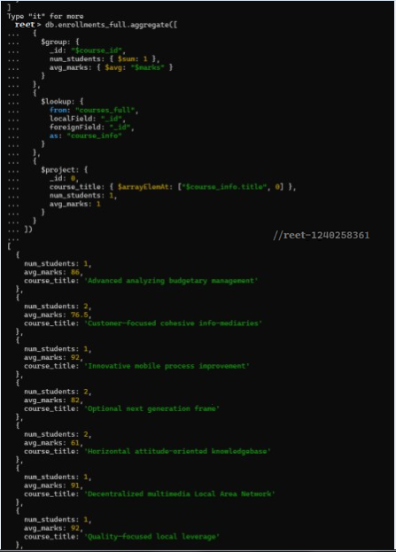
Q5. Find the top 3 students with the highest average marks across all enrolled courses.
Solution: -
db.enrollments_full.aggregate([
{ $group: { _id: "$student_id", average_marks: { $avg: "$marks" } } },
{ $lookup: { from: "students_full", localField: "_id", foreignField: "_id", as: "student" } },
{ $unwind: "$student" },
{ $project: { _id: 0, student_name: "$student.name", average_marks: 1 } },
{ $sort: { average_marks: -1 } },
{ $limit: 3 }
])
Explanation: -
• $group aggregates data by student ID and calculates their average marks.
• $lookup connects this result with the students_full collection to fetch names.
• $sort arranges the students in descending order of marks, and $limit restricts the result to top three performers.
Output: -
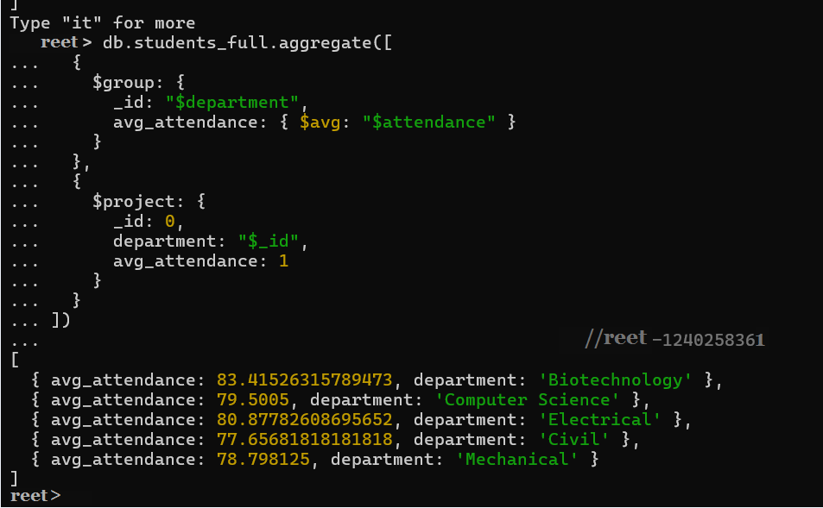

Q6. Count how many students are in each department. Display the department with the highest number of students.
Solution: -
db.students_full.aggregate([
{ $group: { _id: "$department", number_of_students: { $sum: 1 } } },
{ $sort: { number_of_students: -1 } },
{ $limit: 1 },
{ $project: { _id: 0, department: "$_id", number_of_students: 1 } }
])
Explanation: -
• $group collects all students under their department name and counts them using $sum.
• $sort arranges the departments in descending order based on total students.
• $limit selects only the department with the maximum count.
• $project displays the department name and total number of students.
Output: -
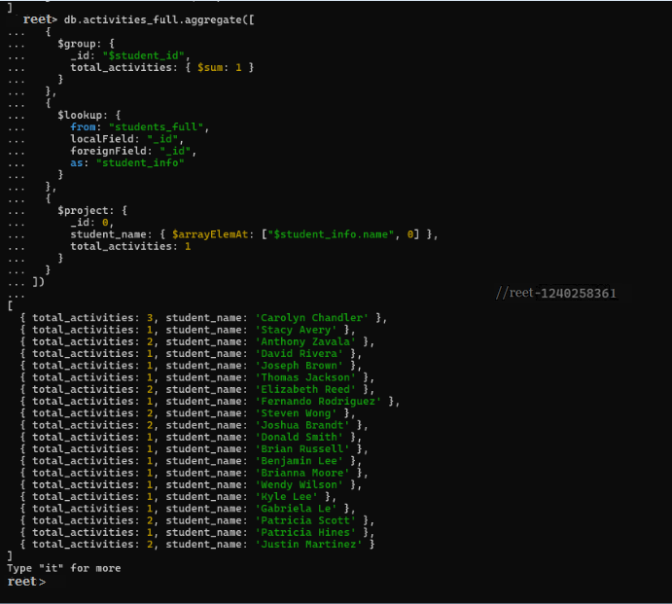
MongoDB Update ,Upsert and Delete
Q7. Update attendance to 100% for all students who won any 'Hackathon'.
Solution: -
Step 1: - db.activities_full.find({ type: "Hackathon", position: "Winner" }, { student_id: 1, _id: 0 })
.toArray().map(a => a.student_id); // extract winner IDs
Step 2: - db.students_full.updateMany({ _id: { $in: winners } }, { $set: { attendance: 100 } })
Explanation: -
• toArray() converts the query cursor into an array for easier access. • .map(a => a.student_id) retrieves only the student IDs of winners. • $in identifies those students within the winners list. • $set updates their attendance field to 100 percent.
Output: -
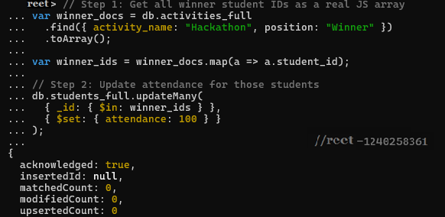
Q8. Delete all student activity records where the activity year is before 2022.
Solution: -
db.activities_full.deleteMany({ year: { $lt: 2022 } })
Explanation: -
• The $lt operator selects all records where the year is less than 2022.
• deleteMany removes every matching record from the activities collection.
Output: -
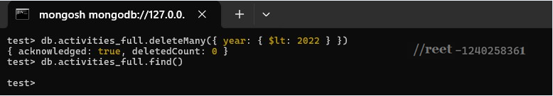
Q9. Upsert a course record for 'Data Structures' with ID 'C150' and credits 4—if it doesn’t exist, insert it; otherwise update its title to 'Advanced Data Structures'.
Solution: -
db.courses_full.updateOne(
{ _id: "C150" },
{ $set: { title: "Advanced Data Structures", credits: 4 } },
{ upsert: true }
)
Explanation: -
• updateOne modifies a single course document. • $set changes the title and credits fields.
• upsert: true ensures that if the record doesn’t exist, MongoDB creates a new one instead.
Output: -
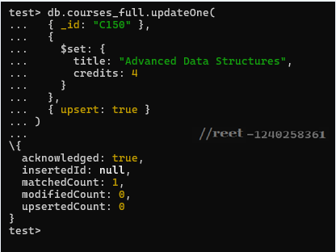
Q10. Find all students who have 'Python' as a skill but not 'C++'.
Solution: -
db.students_full.find({ skills: "Python", skills: { $ne: "C++" } }, { _id: 0, name: 1, skills: 1 })
Explanation: -
• skills: "Python" checks that the skill list includes Python.
• skills: { $ne: "C++" } ensures C++ is not listed.
• The projection { name: 1, skills: 1 } restricts output to student names and their skill sets.
Output: -
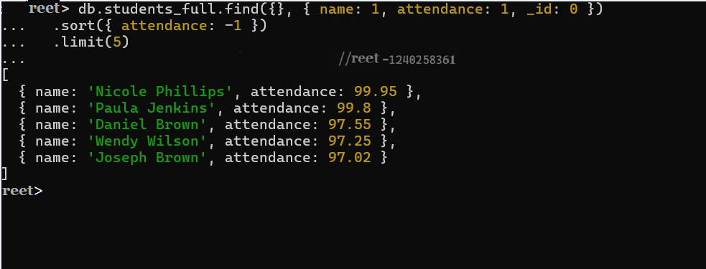
Q11. Return names of students who participated in 'Seminar' and 'Hackathon' both.
Solution: -
db.activities_full.aggregate([
{ $match: { type: { $in: ["Seminar", "Hackathon"] } } },
{ $group: { _id: "$student_id", activities: { $addToSet: "$type" } } },
{ $match: { activities: { $all: ["Seminar", "Hackathon"] } } },
{ $lookup: { from: "students_full", localField: "_id", foreignField: "_id", as: "student" } },
{ $unwind: "$student" },
{ $project: { _id: 0, student_name: "$student.name", activities: 1 } }
])
Explanation: -
• The initial $match filters only 'Seminar' and 'Hackathon' entries.
• $group gathers each student’s activities into a set.
• $match with $all keeps only those who have attended both activities.
• $lookup fetches student details, and $project shows their names with activities.
Output: -
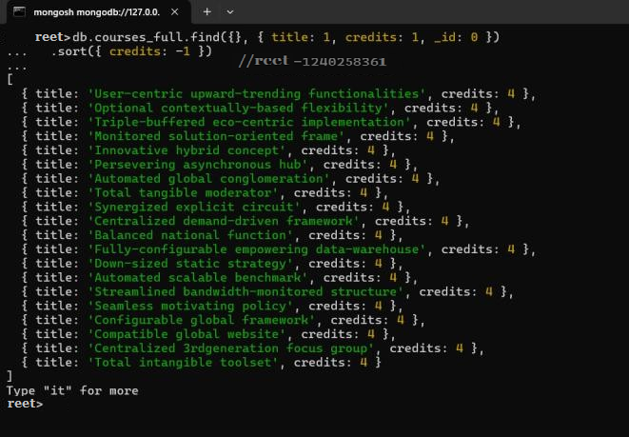
Q12. Find students who scored more than 80 in 'Web Development' only if they belong to the 'Computer Science' department.
Solution: -
db.enrollments_full.aggregate([
{ $lookup: { from: "students_full", localField: "student_id", foreignField: "_id", as: "student" } },
{ $unwind: "$student" },
{ $lookup: { from: "courses_full", localField: "course_id", foreignField: "_id", as: "course" } },
{ $unwind: "$course" },
{ $match: { "marks": { $gt: 80 }, "course.title": "Web Development", "student.department": "Computer Science" } },
{ $project: { _id: 0, student_name: "$student.name", course_title: "$course.title", marks: 1, department: "$student.department" } }
])
Explanation: -
• $lookup connects enrollment data with students and courses.
• $match filters those who scored above 80 in Web Development within Computer Science.
• $project displays the student’s name, course, marks, and department details.
Output: -
Q13. For each faculty member, list the names of all students enrolled in their courses along with average marks per student per faculty.
Solution: -
db.courses_full.aggregate([
{ $lookup: { from: "enrollments_full", localField: "_id", foreignField: "course_id", as: "enrollments" } },
{ $unwind: "$enrollments" },
{ $lookup: { from: "students_full", localField: "enrollments.student_id", foreignField: "_id", as: "student" } },
{ $unwind: "$student" },
{ $group: { _id: "$faculty_id", students: { $addToSet: "$student.name" }, average_marks_per_student: { $avg: "$enrollments.marks" } } },
{ $lookup: { from: "faculty_full", localField: "_id", foreignField: "_id", as: "faculty" } },
{ $unwind: "$faculty" },
{ $project: { _id: 0, faculty_name: "$faculty.name", students: 1, average_marks_per_student: { $round: ["$average_marks_per_student", 2] } } }
])
Explanation: -
• The query links courses, enrollments, and student collections using $lookup.
• $group aggregates students by faculty and computes their mean marks.
• A second $lookup adds faculty names, while $round limits decimal places to two.
Output: -
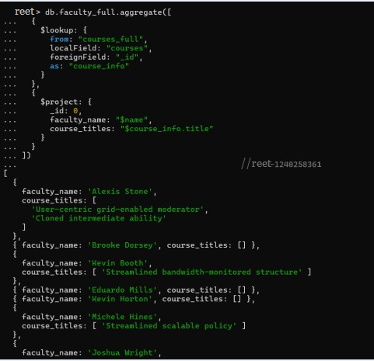
Q14. Show the most popular activity type (e.g., Hackathon, Seminar, etc.) by number of student participants.
Solution: -
db.activities_full.aggregate([
{ $group: { _id: "$type", participants: { $addToSet: "$student_id" } } },
{ $project: { _id: 0, activity_type: "$_id", number_of_participants: { $size: "$participants" } } },
{ $sort: { number_of_participants: -1 } },
{ $limit: 1 }
])
Explanation: -
• $group organizes data by activity type and collects unique student IDs.
• $size counts the total participants per activity.
• $sort arranges activities in descending order, and $limit retrieves the most popular one.
Output: -
